Archi diag

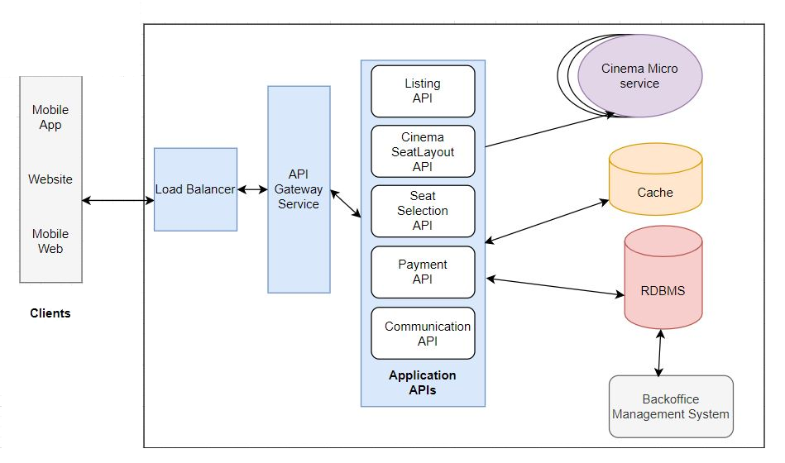

<https://www.freeprojectz.com/uml-diagram/movie-ticket-booking-system-uml-diagram>